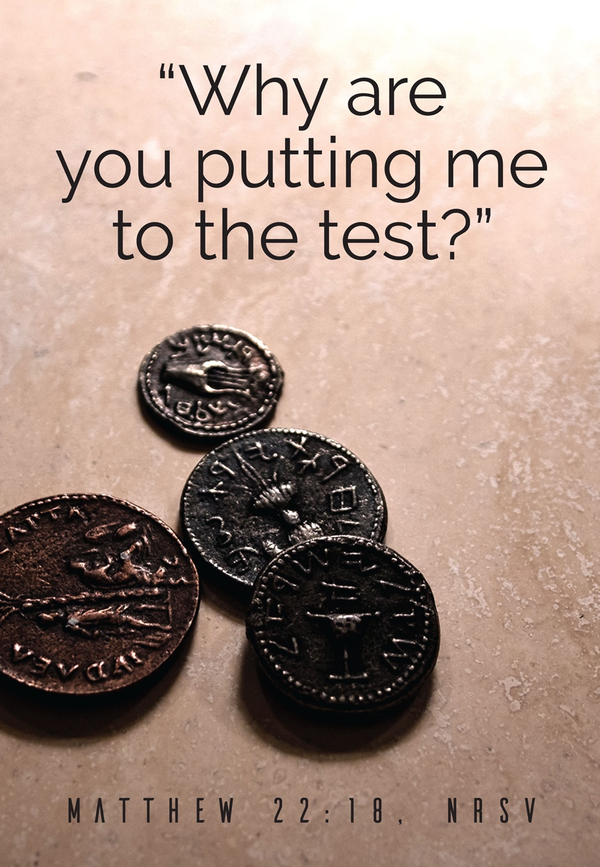
Saint Peter’s Lutheran Church
October 18, 2026

2570 St. Peter’s Church Road, Salisbury, NC 28146
Church Website: https://www.saintpeterslc.org/
Church Email: saintpetersnc@gmail.com

Pastor Sue Lynn White
(cell 770-833-1922) (pastorsuelynn@gmail.com)
Twenty-first Sunday After Pentecost October 18, 2026
* Indicates to stand as you are able. P=Pastor, C=Congregation, A=Assisting Minister, L=Lector
WELCOME & ANNOUNCEMENTS

Prelude

CONFESSION & FORGIVENESS
*P: Blessed be the holy Trinity, ☩ one God, who pours love into our hearts
and healing upon the earth.
*C: Amen.
*P: Confident that God justifies us by grace through faith, let us confess our sin.

Silence is kept for reflection.
Compassionate God,
*C: we confess that we struggle to embody your goodness in the world and in our own hearts. Creation groans from overuse. Jealousy and bitterness strain our relationships. Indifference keeps us from seeking justice. Divisions disrupt your call to show genuine love
to others. Turn our hearts back to you. Restore our world and reconcile us to one another. Renew us to live as your holy people,
following the way of Jesus Christ. Amen.

*P: Hear this good news: We have peace with God through ☩ Jesus Christ,
in whom there is no condemnation, but only forgiveness and the promise of eternal life. Receive freely this healing gift of grace.
*C: Amen.

GATHERING HYMN God of Grace and God of Glory ELW 705

APOSTOLIC GREETING
*P: The grace of our Lord Jesus Christ, the love of God, and the communion of the Holy Spirit be with you all.
*C: And also with you.
PRAYER OF THE DAY
*P: Let us pray. Sovereign God, raise your throne in our hearts. Created by you, let us live in your image; created for you, let us act for your glory; redeemed by you, let us give you what is yours, through Jesus Christ, our Savior and Lord.
*C: Amen.
GOD SPEAKS TO US
First Reading Isaiah 45:1-7
L: A reading from Isaiah the 45th chapter.
¹ Thus says the Lord to his anointed, to Cyrus,
whose right hand I have grasped
to subdue nations before him
and to strip kings of their robes,
to open doors before him—
and the gates shall not be closed:
² I will go before you
and level the mountains;
I will break in pieces the doors of bronze
and cut through the bars of iron;
³ I will give you the treasures of darkness
and riches hidden in secret places,
so that you may know that it is I, the Lord,
the God of Israel, who call you by your name.
⁴ For the sake of my servant Jacob
and Israel my chosen,
I call you by your name;
I give you a title, though you do not know me.
⁵ I am the Lord, and there is no other;
besides me there is no god.
I arm you, though you do not know me,
⁶ so that they may know, from the rising of the sun
and from the west, that there is no one besides me;
I am the Lord, and there is no other.
⁷ I form light and create darkness,
I make weal and create woe;
I the Lord do all these things.
L: The word of the Lord. C: Thanks be to God.
Psalm 96:1-9 [10-13]
¹ Sing to the Lord a new song;
sing to the Lord, all the earth.
² Sing to the Lord, bless the name of the Lord;
proclaim God’s salvation from day to day.
³ Declare God’s glory among the nations
and God’s wonders among all peoples.
⁴ For great is the Lord and greatly to be praised,
more to be feared than all gods.
⁵ As for all the gods of the nations, they are but idols;
but you, O Lord, have made the heavens.
⁶ Majesty and magnificence are in your presence;
power and splendor are in your sanctuary.
⁷ Ascribe to the Lord, you families of the peoples,
ascribe to the Lord honor and power.
⁸ Ascribe to the Lord the honor due the holy name;
bring offerings and enter the courts of the Lord.
⁹ Worship the Lord in the beauty of holiness;
tremble before the Lord, all the earth.
¹⁰ Tell it out among the nations: “The Lord is king!
The one who made the world so firm that it cannot be moved will judge the peoples with equity.”
¹¹ Let the heavens rejoice, and let the earth be glad;
let the sea thunder and all that is in it; let the field be joyful and all that is therein.
¹² Then shall all the trees of the wood shout for joy at your coming, O Lord,
for you come to judge the earth.
¹³ You will judge the world with righteousness
and the peoples with your truth.

Second Reading 1 Thessalonians 1:1-10
L: A reading from Philippians the 3rdchapter
¹ Paul, Silvanus, and Timothy,
To the church of the Thessalonians in God the Father and the Lord Jesus Christ:
Grace to you and peace.
² We always give thanks to God for all of you and mention you in our prayers, constantly ³ remembering before our God and Father your work of faith and labor of love and steadfastness of hope in our Lord Jesus Christ. ⁴ For we know, brothers and sisters beloved by God, that he has chosen you, ⁵ because our message of the gospel came to you not in word only but also in power and in the Holy Spirit and with full conviction; just as you know what kind of persons we proved to be among you for your sake. ⁶ And you became imitators of us and of the Lord, for in spite of persecution you received the word with joy from the Holy Spirit, ⁷ so that you became an example to all the believers in Macedonia and in Achaia. ⁸ For the word of the Lord has sounded forth from you not only in Macedonia and Achaia but in every place your faith in God has become known, so that we have no need to speak about it. ⁹ For they report about us what kind of welcome we had among you and how you turned to God from idols to serve a living and true God ¹⁰ and to wait for his Son from heaven, whom he raised from the dead—Jesus, who rescues us from the coming wrath.
L: The word of the Lord. C: Thanks be to God.
GOSPEL ACCLAMATION
*P: The Holy Gospel according to St. Matthew, the 22nd chapter.
*C: Glory to you, O Lord.
*The Holy Gospel Matthew 22:15-22
¹⁵ The Pharisees went and plotted to entrap [Jesus] in what he said. ¹⁶ So they sent their disciples to him, along with the Herodians, saying, “Teacher, we know that you are sincere, and teach the way of God in accordance with truth, and show deference to no one, for you do not regard people with partiality. ¹⁷ Tell us, then, what you think. Is it lawful to pay taxes to Caesar or not?” ¹⁸ But Jesus, aware of their malice, said, “Why are you putting me to the test, you hypocrites? ¹⁹ Show me the coin used for the tax.” And they brought him a denarius. ²⁰ Then he said to them, “Whose head is this and whose title?” ²¹ They answered, “Caesar’s.” Then he said to them, “Give therefore to Caesar the things that are Caesar’s and to God the things that are God’s.” ²² When they heard this, they were amazed, and they left him and went away.
*P: The Gospel of our Lord. *C: Praise to you, O Christ
Children’s Sermon

The Sermon Pastor Sue Lynn White
*HYMN OF THE DAY Rock of Ages, Cleft for Me ELW 623

*APOSTLES’ CREED
*A: Let us profess our faith using the words of the Apostles’ Creed.
*C: I believe in God, the Father almighty creator of heaven and earth.
I believe in Jesus Christ, God’s only Son, our Lord, who was conceived by the Holy Spirit, born of the virgin Mary, suffered under Pontius Pilate, was crucified, died, and was buried; he descended to the dead.* On the third day he rose again; he ascended into heaven, he is seated at the right hand of the Father, and he will come to judge the living and the dead.
I believe in the Holy Spirit, the holy catholic church, the communion of saints, the forgiveness of sins, the resurrection of the body, and the life everlasting. Amen.

PRAYERS OF INTERCESSION
*A: Seeking the Spirit of God who makes all things new, we pray for the church and the world.
A brief silence.
*A: Living and true God, you inspire us to share the message of the gospel. Give your spirit of love to seminarians and those beginning their lives in ordained ministry. Hear us, O God.
*C: Your mercy is great.

*A: We give you thanks for the majesty of our oceans. Protect the abundant life within them and sustain all those who work to preserve them. Hear us, O God.
*C: Your mercy is great.

*A: We seek your wisdom in all things. Direct all who hold positions of authority around the world, that they act with compassion, seeking the good of all. Hear us, O God.
*C: Your mercy is great.

*A: We pray for all people who work in dangerous or degrading environments. Grant them safety and courage, and heal all those who are injured, sick, or suffering. We especially pray for Guy & Betty Puckett, Jim & Phyllis Cornelison, Jerry & Carolyn Sides, Ernie & Linda Cooper, Phil & Carol Boyette, George Lentz, Brenda H. Trexler, Judy Peeler, Lynn DeBerry, Marcia Ritchie, Jean Holshouser, Sue Misenheimer, Thelma Barger, Buddy Waller, Ronnie Pierce, Bobby Lambirth, friends of St. Peter’s, and those we hold in our hearts or speak aloud now… (pause). Hear us, O God. *C: Your mercy is great.

*A: We ask your blessing on those who do the quiet, unseen work of the church (congregational ministries may be named). Encourage them in their work of faith and labor of love. Hear us, O God.
*C: Your mercy is great.

*A: We thank you for our ancestors who have been called home to you. Hear us, O God.
*C: Your mercy is great.

*P: Trusting in your boundless grace, O God, we lift up these spoken prayers and those in our hearts; through Jesus Christ our Lord.
*C: Amen.

PEACE
*P: The peace of Christ be with you always. *C: And also with you.
*P: Let us share the peace with one another.

THE OFFERING
Anthem
Offering Hymn Now the Feast and Celebration ELW 167

OFFERING PRAYER
*A: Let us pray. God of creation, you send rain and the earth springs forth abundantly. All blessings are from you; make us generous with what we have. Use our gifts, our abilities, and our hearts in service to you and in love to our neighbors, today and always.
*C: Amen.

MEAL
PREFACE DIALOGUE
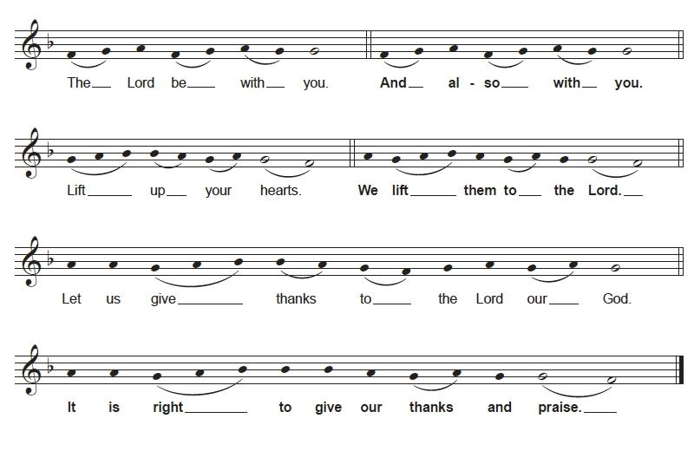
*P: It is indeed right, our duty and our joy, that we should at all times and in all places give thanks and praise to you, almighty and merciful God,
through our Savior Jesus Christ; who on this day overcame death and the grave, and by his glorious resurrection opened to us the way of everlasting life. And so, with all the choirs of angels, with the church on earth and the hosts of heaven, we praise your name and join their unending hymn:

*C: Holy, Holy, Holy
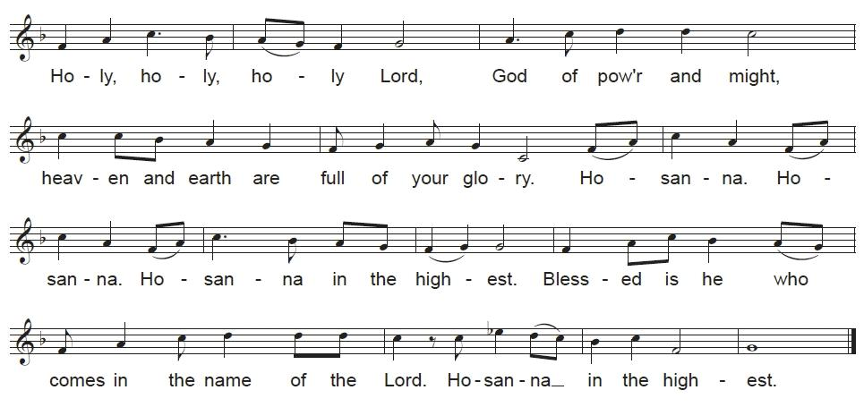
WORDS OF INSTITUTION
LORD’S PRAYER
*P: Gathered into one by the Holy Spirit, let us pray as Jesus taught.
*C: Our Father, who art in heaven,
hallowed be thy name,
thy kingdom come,
thy will be done,
on earth as it is in heaven.
Give us this day our daily bread;
and forgive us our trespasses,
as we forgive those
who trespass against us;
and lead us not into temptation,
but deliver us from evil.
For thine is the kingdom,
and the power, and the glory,
forever and ever. Amen.

INVITATION TO COMMUNION
*P: Christ invites you to this table. All who are thirsty, all who are hungry, come!
LAMB OF GOD
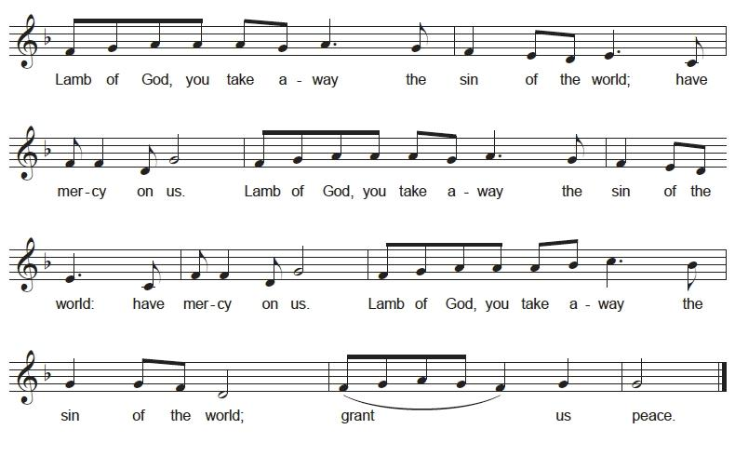
DISTRIBUTION

COMMUNION BLESSING
*P: The body and blood of our Lord and Savior Jesus Christ, strengthen you and keep you in God’s grace. Amen.

PRAYER AFTER COMMUNION
*A: Let us pray. Sustaining God, with this bread and cup, you nourish us with mercy and abundant life. By your Spirit, send us from this table to serve a needy world. Make us living signs of your liberation, healing, and love, following the way of Jesus, in whose name we pray.
*C: Amen.

SENDING OF GOD’S PEOPLE

BLESSING
*P: The God of love draw you into full accord and one mind, in the body of Christ Jesus.
*C: Amen.
*P: The God of hope grant you strength and joy in all circumstances
through the interceding of the Spirit.
*C: Amen.
*P: The God of grace ☩ bless you now and forever.
*C: Amen.

*SENDING HYMN Lord, Dismiss Us With Your Blessing ELW 545

THE DISMISSAL
*A: Rooted in the love of Christ;
*C: We grow in grace and joyfully branch into a broken world!

*P: Go out in joy. Be led forth in peace.
*C: Thanks be to God.

