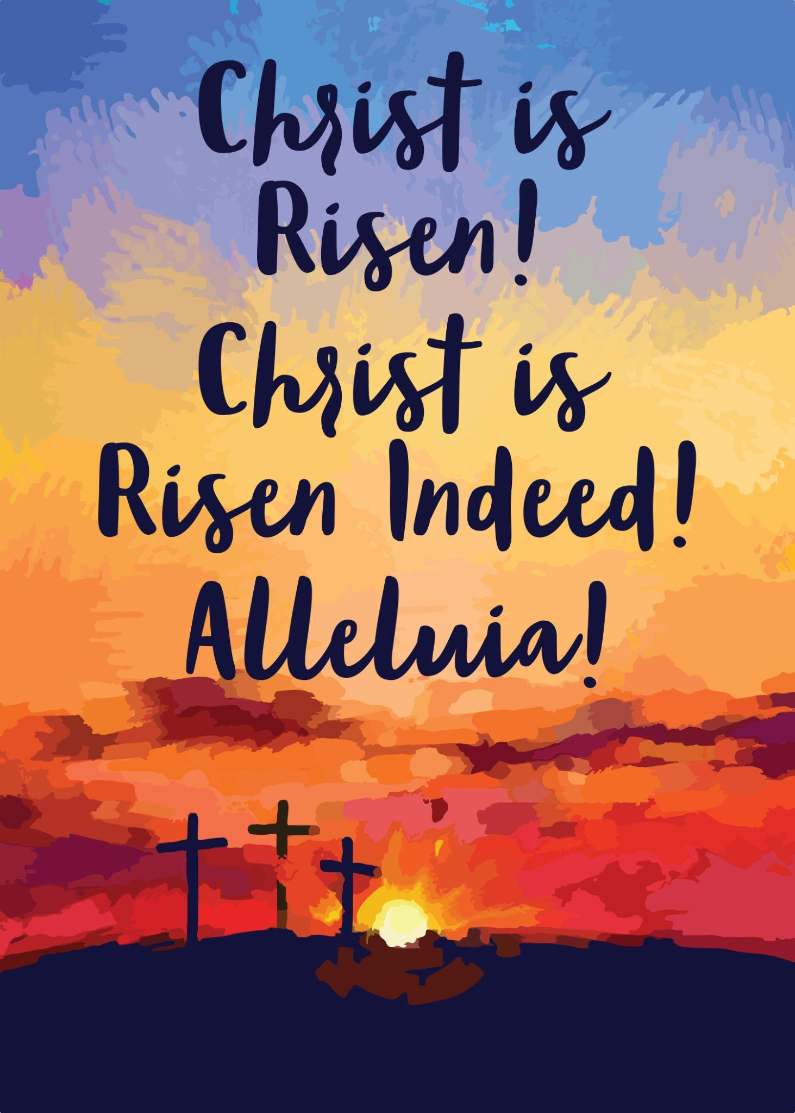

Saint Peter’s Lutheran Church
April 21st, 2024
2570 St. Peter’s Church Road, Salisbury, NC 28146
Church Website: https://www.saintpeterslc.org/
Church Email: saintpetersnc@gmail.com
Pastor Sue Lynn White
(cell 770-833-1922) (pastorsuelynn@gmail.com)

4th Sunday of Easter: April 21st, 2024
* Indicates to stand as you are able. P=Pastor, C=Congregation, A=Assisting Minister, L=Lector

WELCOME & ANNOUNCEMENTS

PRELUDE

THANKSGIVING FOR BAPTISM
*P: Blessed be the holy Trinity, ☩ one God, the wellspring of grace, our Easter and our joy. *C: Amen.

*P: Look, here is water!
*C: Here is our water of life! Alleluia!

*P: Immersed in the promises of baptism, let us give thanks for what God has done for us. We give you thanks, O God, for in the beginning your voice thundered over the deep and water became the essence of life. Adam and Eve beheld Eden’s verdant rivers. The ark carried your creation through the flood into a new day. Miriam led the dancing as your people passed through the sea into freedom’s land. In a desert pool the Ethiopian official entered your boundless baptismal life.

*P: Look, here is water!
*C: Here is our water of life! Alleluia!

*P: At the river your beloved Son was baptized by John and anointed with the Holy Spirit. By the baptism of Jesus’ death and resurrection you opened the floodgates of your reconciling love, freeing us to live as Easter people. We rejoice with glad hearts, giving all honor and praise to you, through the risen Christ, our source of living water, in the unity of the Holy Spirit, now and forever. *C: Amen.

*P: Look, here is water!
*C: Here is our water of life! Alleluia!

*GATHERING…”Christ the Lord is Risen Today”…..ELW 369

KYRIE SETTING 10……………………………………………p. 203
CANTICLE OF PRAISE SETTING 10…GLORY BE……….p. 204

APOSTOLIC GREETING
*P: The grace of our Lord Jesus Christ, the love of God, and the communion of the Holy Spirit be with you all. *C: And also with you.

PRAYER OF THE DAY
*P: Let us pray. O Lord Christ, good shepherd of the sheep, you seek the lost and guide us into your fold. Feed us, and we shall be satisfied; heal us, and we shall be whole. Make us one with you, for you live and reign with the Father and the Holy Spirit, one God, now and forever. *C: Amen.

GOD SPEAKS TO US
First Reading…………………………………………….Acts 4:5-12
L: A reading from Acts the 4th chapter …………(Jan McCulloh)
⁵The next day [the] rulers, elders, and scribes assembled in Jerusalem, ⁶with Annas the high priest, Caiaphas, John, and Alexander, and all who were of the high-priestly family. ⁷When they had made the prisoners stand in their midst, they inquired, “By what power or by what name did you do this?” ⁸Then Peter, filled with the Holy Spirit, said to them, “Rulers of the people and elders, ⁹if we are questioned today because of a good deed done to someone who was sick and are asked how this man has been healed, ¹⁰let it be known to all of you, and to all the people of Israel, that this man is standing before you in good health by the name of Jesus Christ of Nazareth, whom you crucified, whom God raised from the dead. ¹¹This Jesus is
‘the stone that was rejected by you, the builders;
it has become the cornerstone.’
¹²There is salvation in no one else, for there is no other name under heaven given among mortals by which we must be saved.”
L: The word of the Lord C: Thanks be to God

Psalm 23
¹The Lord is my shepherd;
I shall not be in want.
²The Lord makes me lie down in green pastures
and leads me beside still waters.
³You restore my soul, O Lord,
and guide me along right pathways for your name’s sake.
⁴Though I walk through the valley of the shadow of death, I shall fear no evil;
for you are with me; your rod and your staff, they comfort me.
⁵You prepare a table before me in the presence of my enemies;
you anoint my head with oil, and my cup is running over.
⁶Surely goodness and mercy shall follow me all the days of my life,
and I will dwell in the house of the Lord forever.

Second Reading……………………..………1 John 3:16-24
L: A reading from 1 John the 3rd chapter ….(Jan McCulloh)
¹⁶We know love by this, that [Jesus Christ] laid down his life for us—and we ought to lay down our lives for one another. ¹⁷How does God’s love abide in anyone who has the world’s goods and sees a brother or sister in need and yet refuses help?
¹⁸Little children, let us love, not in word or speech, but in truth and action. ¹⁹And by this we will know that we are from the truth and will reassure our hearts before him ²⁰whenever our hearts condemn us; for God is greater than our hearts, and he knows everything. ²¹Beloved, if our hearts do not condemn us, we have boldness before God; ²²and we receive from him whatever we ask, because we obey his commandments and do what pleases him.
²³And this is his commandment, that we should believe in the name of his Son Jesus Christ and love one another, just as he has commanded us. ²⁴All who obey his commandments abide in him, and he abides in them. And by this we know that he abides in us, by the Spirit that he has given us.

L: The word of the Lord C: Thanks be to God

GOSPEL ACCLAMATION
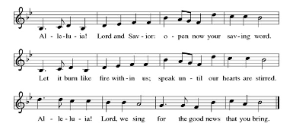
*P: The Holy Gospel according to St. John, the 10th chapter.
*C: Glory to you, O Lord.

John 10:11-18
[Jesus said:] ¹¹“I am the good shepherd. The good shepherd lays down his life for the sheep. ¹²The hired hand, who is not the shepherd and does not own the sheep, sees the wolf coming and leaves the sheep and runs away—and the wolf snatches them and scatters them. ¹³The hired hand runs away because a hired hand does not care for the sheep. ¹⁴I am the good shepherd. I know my own and my own know me, ¹⁵just as the Father knows me and I know the Father. And I lay down my life for the sheep. ¹⁶I have other sheep that do not belong to this fold. I must bring them also, and they will listen to my voice. So there will be one flock, one shepherd. ¹⁷For this reason the Father loves me, because I lay down my life in order to take it up again. ¹⁸No one takes it from me, but I lay it down of my own accord. I have power to lay it down, and I have power to take it up again. I have received this command from my Father.”

*P: The Gospel of our Lord. *C: Praise to you, O Christ

Special Music & Video……………St. Peter’s Lutheran Preschool
The Sermon………………………………Pastor Sue Lynn White

*Hymn of the Day….”The Lord’s My Shepherd”…....ELW 778

*APOSTLES’ CREED…..……(Assistant Minister: Jan McCulloh)
*A: Let us profess our faith using the words of the Apostles’ Creed.
*C: I believe in God, the Father almighty creator of heaven and earth.

I believe in Jesus Christ, God’s only Son, our Lord, who was conceived by the Holy Spirit, born of the virgin Mary, suffered under Pontius Pilate, was crucified, died, and was buried; he descended to the dead.* On the third day he rose again; he ascended into heaven, he is seated at the right hand of the Father, and he will come to judge the living and the dead.

I believe in the Holy Spirit, the holy catholic church, the communion of saints, the forgiveness of sins, the resurrection of the body, and the life everlasting. Amen.

PRAYERS OF INTERCESSION
*A: Rejoicing that Jesus is risen and love has triumphed over fear, let us pray for the church, the world, and all those in need of good news.
Shepherding God, gather your church whenever we wander from you and one another. Empower our church in ministries around the world to worship and serve alongside global companions as equal partners and coworkers in the gospel. God of grace,
*C: hear our prayer.

Nurturing God, preserve the health of biomes and ecosystems. Inspire scientists, researchers, conservation organizations, and all people entrusted with the task of caring for creation, that we may be better stewards of the world around us. God of grace,
*C: hear our prayer.

Almighty God, lead nations and communities to share resources, cooperate in solving conflicts, and listen to the wisdom of Indigenous peoples. Help all those with power to share it and to use such power for good. God of grace,
*C: hear our prayer.

Loving God, protect the very young and the very old, those living without housing, victims of domestic abuse, and all who live with chronic illness or compromised immune systems. We especially lift up Marlene Shue, Rose Swicegood, John Trexler, Guy & Betty Puckett, Jim & Phyllis Cornelison, Frank King, Jerry Sides, Ernie & Linda Cooper, Phil & Carol Boyette, Ruth Shaver, Brenda H. Trexler, Kathie Brown, Debbi Duke, Ellen Troutman, Glenda Vickers, Lynn DeBerry, George Lentz, friends of St. Peter’s and all we hold in our hearts or speak aloud now. Guide communities to actively care for people who are vulnerable. God of grace,
*C: hear our prayer.

Gracious God, help this and all communities of faith to listen for your voice. Call us away from things that distract us from following you. Invite us to more deeply love and serve people who are lonely, isolated, and on the margins. God of grace,
*C: hear our prayer.

Living God, we give thanks for our ancestors in faith including Anselm of Canterbury and all who labored to help generations understand the good news of the gospel. Strengthen us to share the good news in our own day. God of grace,
*C: hear our prayer.

*P: Into your hands, most merciful God, we commend all for whom we pray, trusting in your abiding love; through Jesus Christ, our resurrected and living Lord.
*C: Amen.

PEACE
*P: The peace of Christ be with you always.
*C: And also with you.
*P: Let us share the peace with one another.

THE OFFERING
Anthem:.............................................................”Christ is Risen”
“We Are an Offering”.....................................................ELW 692

OFFERING PRAYER
*A: Risen One, you call us to believe and bear fruit. May the gifts that we offer here be signs of your abiding love. Form us to be your witnesses in the world, through Jesus Christ, our true vine.
*C: Amen.

MEAL

PREFACE DIALOGUE (spoken)
*P: The Lord be with you.
*C: And also with you.
*P: Lift up your hearts.
*C: We lift them to the Lord.
*P: Let us give thanks to the Lord our God.
*C: It is right to give our thanks and praise.

*P: It is indeed our duty and our joy… and join their unending hymn:
*C: Holy, Holy, Holy

HOLY, HOLY, HOLY

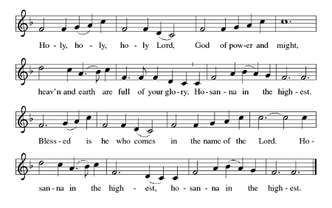

WORDS OF INSTITUTION

LORD’S PRAYER
*P: Gathered into one by the Holy Spirit, let us pray as Jesus taught.
*C: Our Father, who art in heaven, hallowed be thy name,
thy kingdom come, thy will be done, on earth as it is in heaven. Give us this day our daily bread; and forgive us our trespasses, as we forgive those who trespass against us; and lead us not into temptation, but deliver us from evil. For thine is the kingdom, and the power, and the glory, forever and ever.
Amen

INVITATION TO COMMUNION
*P: The risen Christ is made known to us in the breaking of the bread. Come and eat at God’s table. *C: Thanks be to God.

LAMB OF GOD
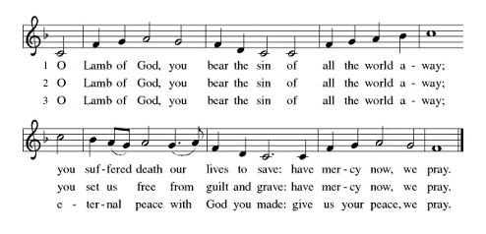

DISTRIBUTION

COMMUNION BLESSING
*P: The body and blood of our Lord and Savior Jesus Christ, strengthen you and keep you in God’s grace. Amen.

POST COMMUNION HYMN……………………………….ELW 207

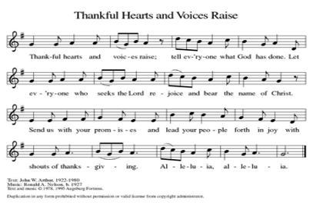

PRAYER AFTER COMMUNION
*A: Shepherding God, you have prepared a table before us and nourished us with your love. Send us forth from this banquet to proclaim your goodness and share the abundant mercy of Jesus, our redeemer and friend. *C: Amen.

SENDING OF GOD’S PEOPLE

BLESSING
*P: Alleluia! Christ is risen!
*C: Christ is risen indeed! Alleluia!
*P: The God of resurrection power, the Christ of unending joy, and the Spirit of Easter hope ☩ bless you now and always.
*C: Amen.

*SENDING HYMN..”God Be With You Till We Meet Again” ELW 536

THE DISMISSAL
*A: Rooted in the love of Christ
*C: We grow in grace and joyfully branch into a broken World!

*P: Alleluia! Go in peace. Rejoice and be glad.
*C: Thanks be to God.

*Silent Prayer and Chiming of the Trinity

Postlude

